Wolfson College top-ups system
College Top-ups – information for graduate students
Overview of College Top-ups
Your College Top-up account operates on an advance payment basis. You will be able to put credit on your College Top-up account by making a card payment using the Wolfson Gateway online system https://gateway.wolfson.ox.ac.uk/
Once your College Top-up account is in credit, you will be able to incur charges (meals, café etc) against your account by presenting your University card at College tills. Other items (e.g. event bookings on the Gateway) can also be charged against College Top-up credit. Please note that costs for printing in the College library are charged against Top-up balances via an overnight process rather than instantly.
How to top-up your account
There is a top-up facility on the Wolfson Gateway website. Payment is made by debit or
credit card.
- Go to the Wolfson Gateway site at https://gateway.wolfson.ox.ac.uk/
- Log in using your University single sign on
- Go to “Top-ups & Tills” on the main menu tabs
- Complete the payments section (example screen shot below), taking care to select “1-COLLEGE TOP-UP”. The minimum top-up is currently £10. Click “Make Payment” and fill in your debit/credit card details to make payment.
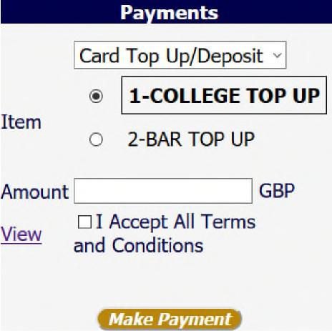
Viewing your College Top-up balance and transactions
Your College Account balance and transactions may also be viewed online on the same
“Top-ups & Tills” page of the Wolfson Gateway.

Any problems?
Should you have any IT problems using this facility, please contact Wolfson IT team on it-support@wolfson.ox.ac.uk. However, if it is a banking related problem then please contact your own payment card provider.
For any other queries on your Top-up transactions, please email battels@wolfson.ox.ac.uk
Bar Top-ups
The Cellar Bar operates a separate top-up system for bar purchases. If you wish to top-up this account, please use the same page on the Gateway to make payment but select “2-BAR TOP-UP” as per example screen shot below.
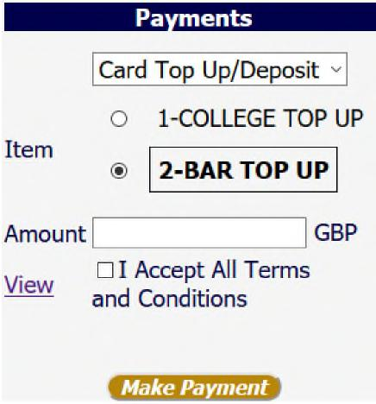

Fees, battels and other charges
Course fees
Course fees for the full academic year are payable to Wolfson College prior to the start of the term in which study commences.
If you are a self-financed student, you should expect to receive an invoice by email in early September. The College does not offer payment by instalments.
If you are in receipt of a scholarship, Wolfson will invoice your funding body directly, provided the details of your funding body are held on file in the College. please ensure you have provided all relevant information to the Academic Office
Please contact academic.fees@wolfson.ox.ac.uk if you have any questions regarding fees.
Battels system
Each student at Wolfson also has an account with the College known as “Battels”. The following charges are added to this account:
- Monthly rent, if you are in Wolfson accommodation
- key deposits charge which will be refunded when you hand back keys
- Any other College charges which you incur that cannot go through the Top-up system
Battels statements are sent by email each month, and must be paid in full by the due date specified on the statement.

Please note a “ – “ in front of the total figure shows you have a credit balance which can be left on your account to be set against future charges.

Battels payments should be paid via the Wolfson Gateway. Alternatively, please contact battels@wolfson.ox.ac.uk for a direct debit form if you wish to use this method of payment. Please note these can only be processed against a UK bank account.

If paying by bank transfer you must quote your College Member Number
(5 digits in length found at the top right on your Battels statement) plus surname as the reference so that we can identify the funds.

Payments via transfermate can be made by following the instructions at: https://wolfsoncollegeoxford.transfermateeducation.com
If have any problem topping up online, credit can alternatively be put on your account via
debit/credit card machine at the Accounts Office in the Berlin Quad, office hours
Mon-Fri 9.30am-4.30pm

Please contact battels@wolfson.ox.ac.uk if you have any questions regarding battels.
Please note Wolfson is not part of the banking system and so 48 hours should be
allowed for payments to be processed to your Battels account.

